**THERMAL CAMERA SYSTEM**

**QUICK INSTRUCTION**

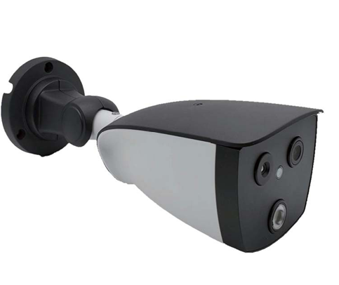

**Version-WT-C15000**

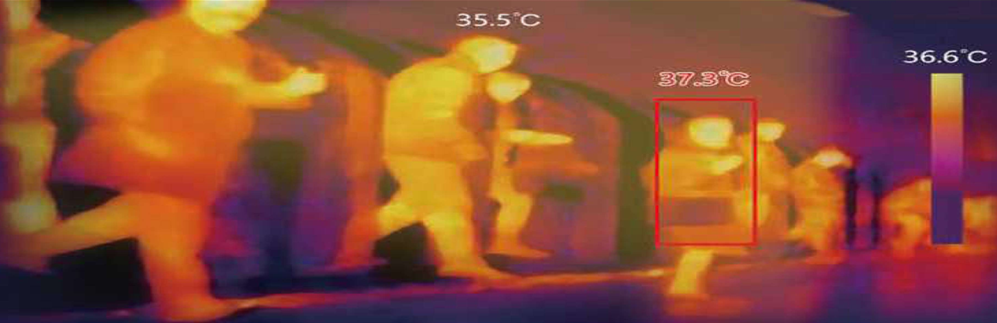

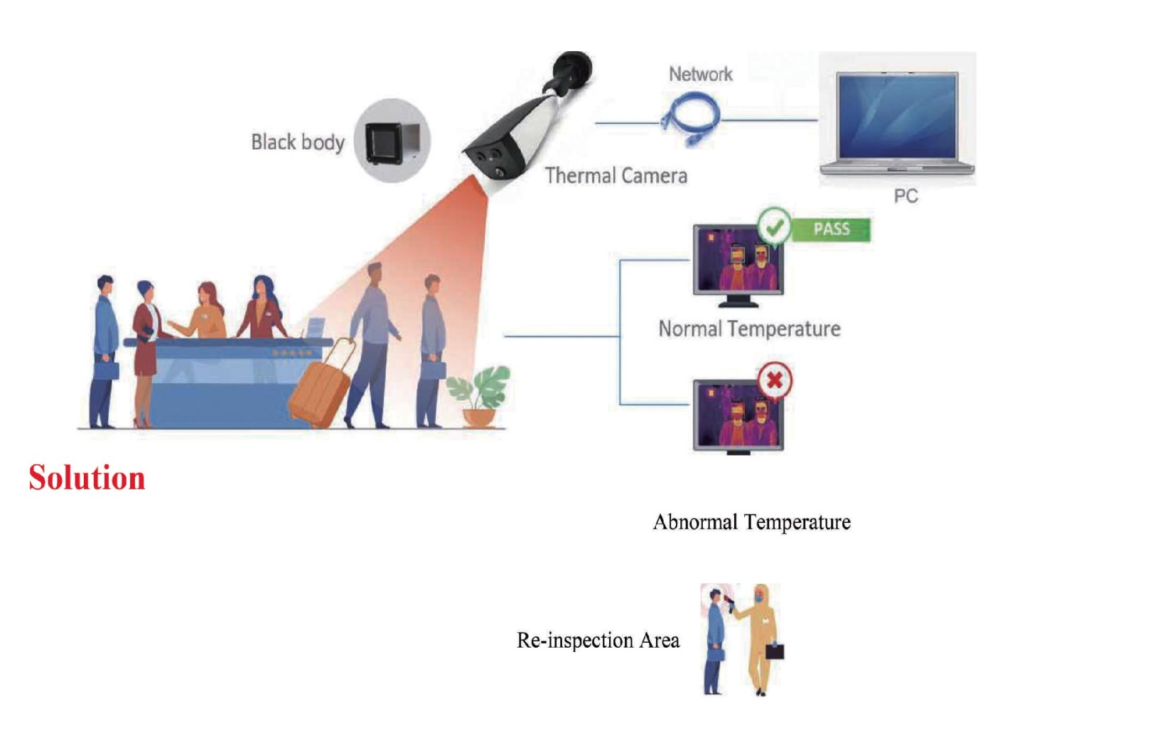

**Contents**

1. Product Introduction 3
   1. Product Description 3
   2. Product Appearance 3
2. Device Installation 4
   1. Installation Position 4
   2. I nstallation Environment Standard 4
3. Quick Instructions 4
   1. Device Connection 4
   2. AI Thermal Imaging Screening Sytem 5
      1. Main Interface Introduction 5
      2. Snapshot Folder 6
      3. Setting 6
4. Device Upgrade 7
   1. Web Upgrade 7
   2. Tool Upgrade Program 8

# Product Introduction

* 1. **Product Description**

This Intelligent AI binocular thermal imaging system is composed of AI binocular temperature detecting camera and AI thermal imaging screening system. Integrated by thermal temperature detecting sensor of high-accuracy, built-in intelligent face capture algorithm, and ISP image processing technology etc, this device is with face detection, temperature detection and face capture, etc powerful features. With AI thermal imaging screening system, it can accurately detecting the body temperature, capturing face pic and records for those people appeared in front of this device.It can effectively help to monitor and detect the body temperature of entry and exit people ,thus contributing to prevent epidemic situation. It can be widely used at all kinds of entrances and exits of school, buildings, stations, etc.

* 1. **Product Appearance**

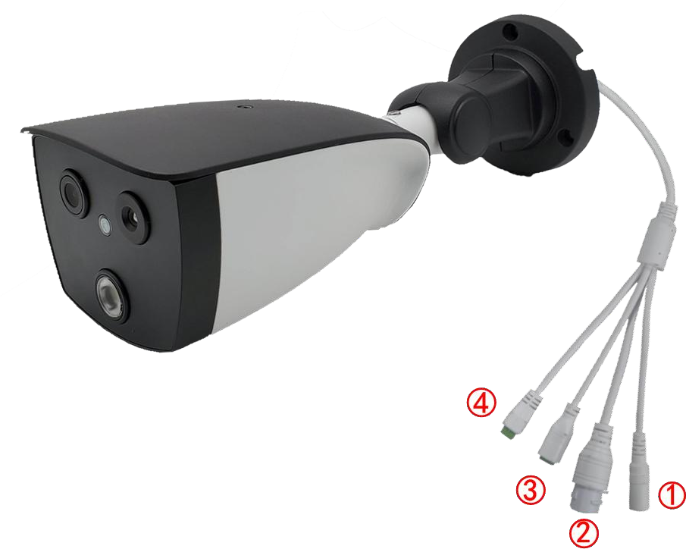

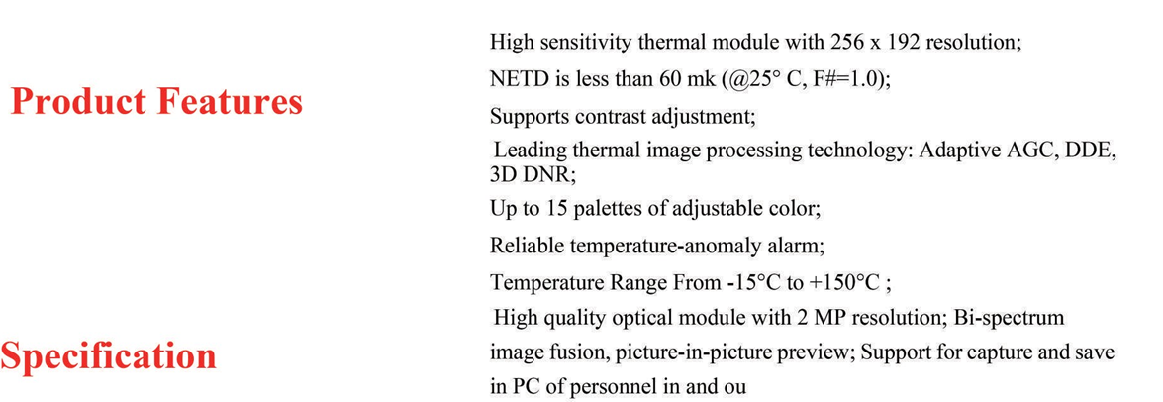

**Device Interface Function Definition**

|  |  |  |
| --- | --- | --- |
| **Interface No.** | **Interface Name** | **Functional Indicators** |
| **1** | Power Interface | 12VDC |
| **2** | Network Interface | RJ45 Network Interface |
| **3** | Relay Interface | +：NO Normally Open Port  -：COM Public Port |
| **4** | Audi Interface | 1: Audio Input  2: Audio Ground  3: Audio Output  4: Empty |

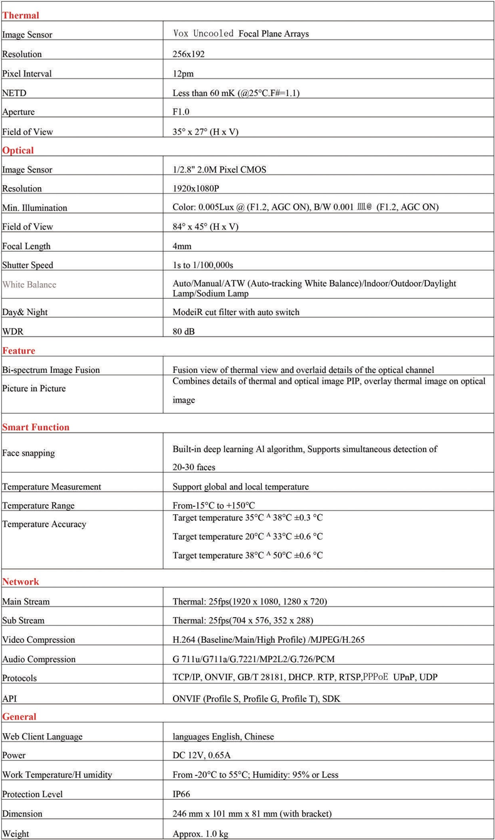

# Device Installation

* 1. **Installation Position**

1. Camera being set in front of the aisle to capture the face;
2. Suggested installation height is about 2 meters, and camera overlook view angle 0~15°; 3.For accurate detection of body temperature,1 meters(Range 1m to 2.5m)distance are tested for the optimum capture distance.
   1. **I nstallation Environment Standard**
3. Illumination Requirements: No backlight, no obviously reflect light on face, uniform light and no shadow. In addition, to ensure the enough illumination of the scene when capturing the face, it is suggested to increase the lighting devices if the face in the display is not bright enough which may effect the face capture(General 250~800Lux).
4. 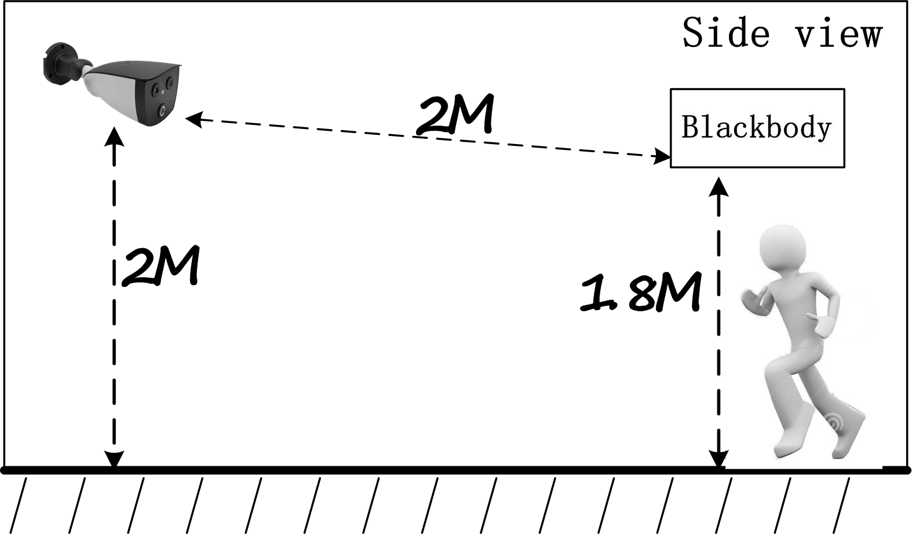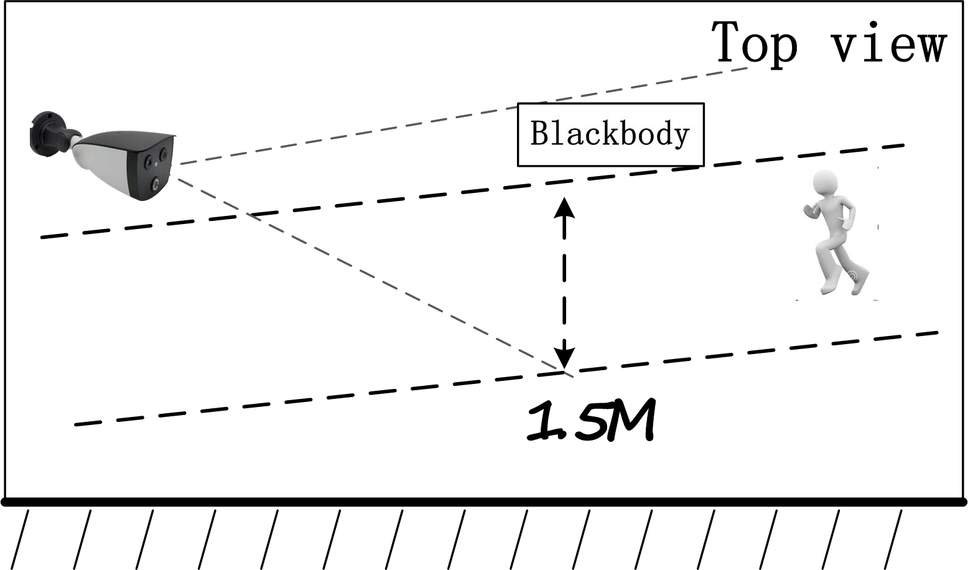Light and Wind Requirements: This Device is suggested to be installed indoor, ensuring there is no wind between device and people, no direct sunlight, so as to avoid the detected temperature too low or too high caused by blowing ,cooling and direct sunlight.

# Quick Instructions

* 1. **Device Connection**

Connect the device to the computer correctly through network cable; After the device powered on, open the search tool on the computer,s earch device IP address. User can also modify the IP address by search tool at the same time.

Notice: Default device IP address is 192.168.1.18.

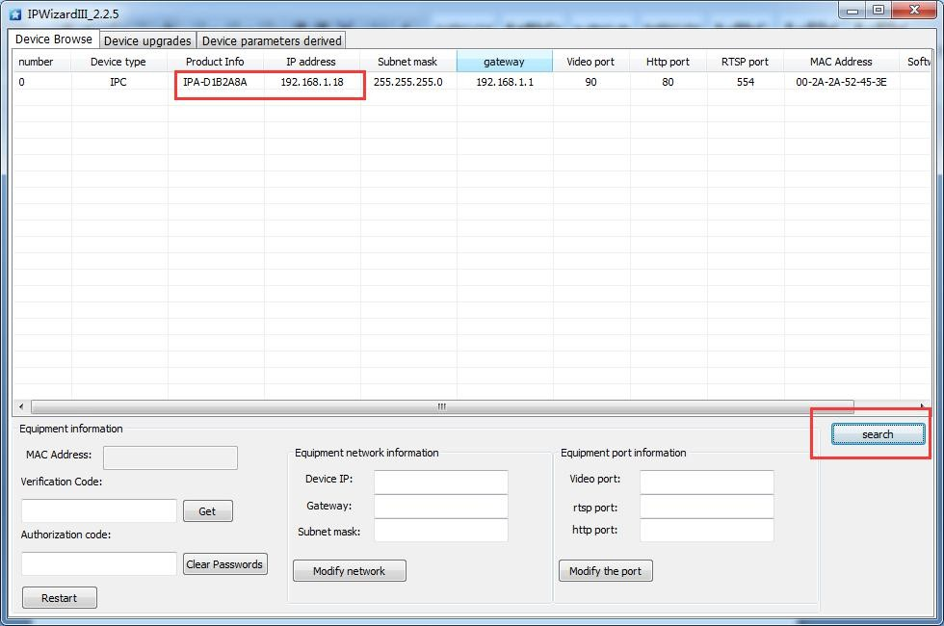

* 1. **AI Thermal Imaging Screening Sytem**

After device powered on, user can use AI thermal imaging screening system software to connect device, preview, setting, alarm clean, snapshot pic preview, export records, etc operation.

* + 1. **Main Interface Introduction**

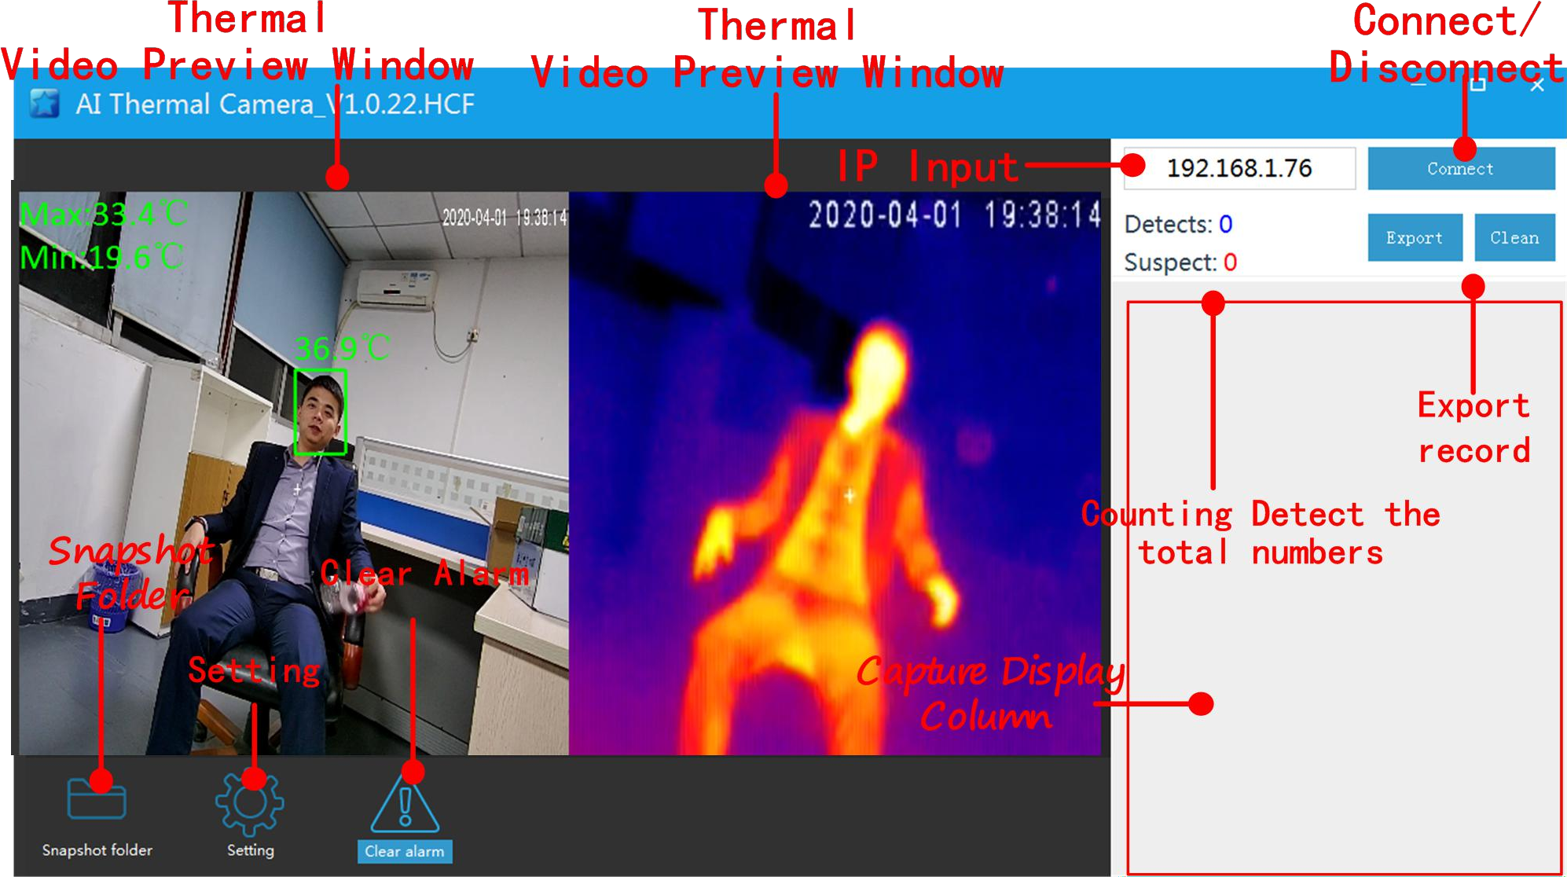

**【Video Preview Window】:** After device connected, user can view double screen(optical and thermal imaging)for real-time preview as above pic shows;

**【IP Input Box】:** Input device’s IP address. The device default IP address is 192.168.1.18;

【 **Connect/Disconnect Device Button** 】 **:** Click 【 Connect 】 to view the real-time display,facecapture pic and temperature detecting.Click 【 Disconect 】 to

close the preview;

**【Capture Display Column】:**List the current captured face pic and detecting temperature;。

**【Snapshot Folder】:** Click the snapshot folder to check saved captured face;

**【Setting】:** Click to modify the settings for face capture and temperature detecting alarm;

**【Clear Alarm】:** After click,the alarm will be canceled;

**【Detects】:** Counting the total numbers of face capture and shows;

**【 Suspect 】 :** Counting the total number of face capture for those abovethe high temperature limit setting and shows;

**【Export】:** Export counting records and saved as excel file;

**【Clean】:** Clear the total records.

* + 1. **Snapshot Folder**

To click the **【Snapshot Folder】,you can check all the capturedface pics.**

Notice: The folder is named by the date.

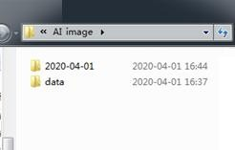

* + 1. **Setting**

Click【**Setting**】button to enter into the interface to modify the setting;

**【On/Off】:** Turn On/Off to temperature alam function;

**【 HighLimit**℃ **】 :** Alarm When detecting temperature higher than the high limit℃;

**【Duration(S)】:** Temperature alarm duration time, default is 10 seconds;

**【Confidence】:** Reserved, the reliability of judging an image as a face;

**【Capture Interv(MS)】:** The interval time of Same people repeat face capture;

**【Select Mode(0-1) :** 0 indicates asile environemntk,1 indicates indoor environment;

**【Face Deduplication (0-1)】:** Same people only capture once, no repeat snapshot;

**【 Correction**℃ **】 :** Under the severe environment ,it will increase the compensation temperature to improve the accuracy of temperature measurement, time-of-use

compensation can be set.

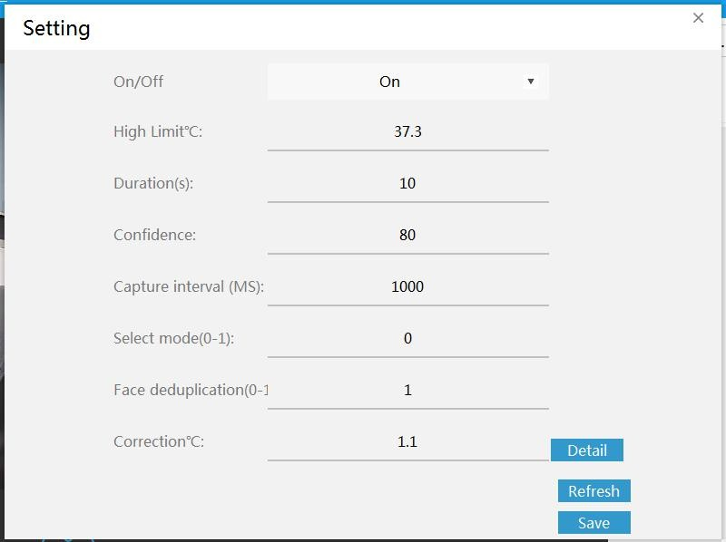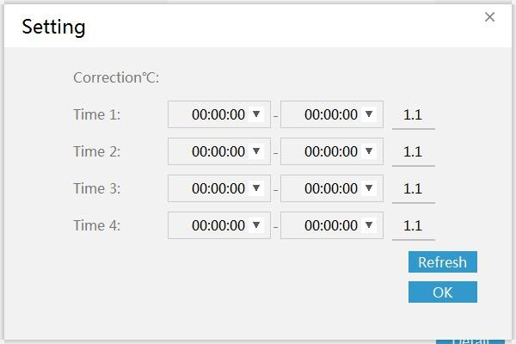

# Device Upgrade

Users can use browser or PC tool for upgrade;

Notice: Brower upgrade package suffix is .ifu. PC tool upgrade package suffix is .bin

* 1. **Web Upgrade**

Notice: Only IE browser,QQ browser,and 360 security browser isworkable; IE Edge browser,360 speed browser are not able to use.

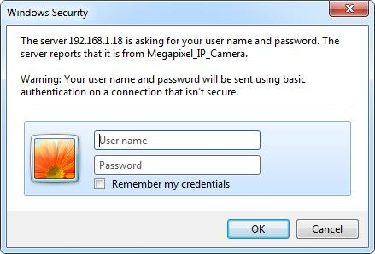Step 1: Open Browser,input device IP address,and input the user name” admin” and password” admin”.

Step 2: Click “setting”-“Setting”-“Maintain” to enter into the uprade interface; Step 3: Click” Browse” to choose “app.ifu” updgrade file;

Step 4: Click “Upload” button to start upgrading,after upgrade completed,the web page will auto-refresh.

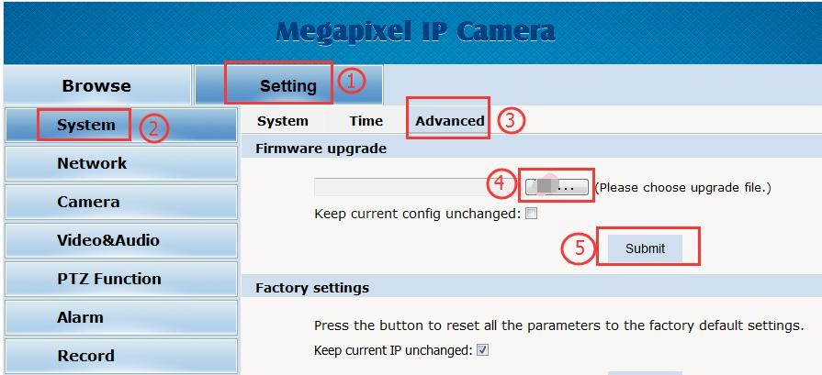

* 1. **Tool Upgrade Program:**

Step 1: Open the PC to search tool **IPWIZARD** and above version,select the device and upgrade directly for single device;

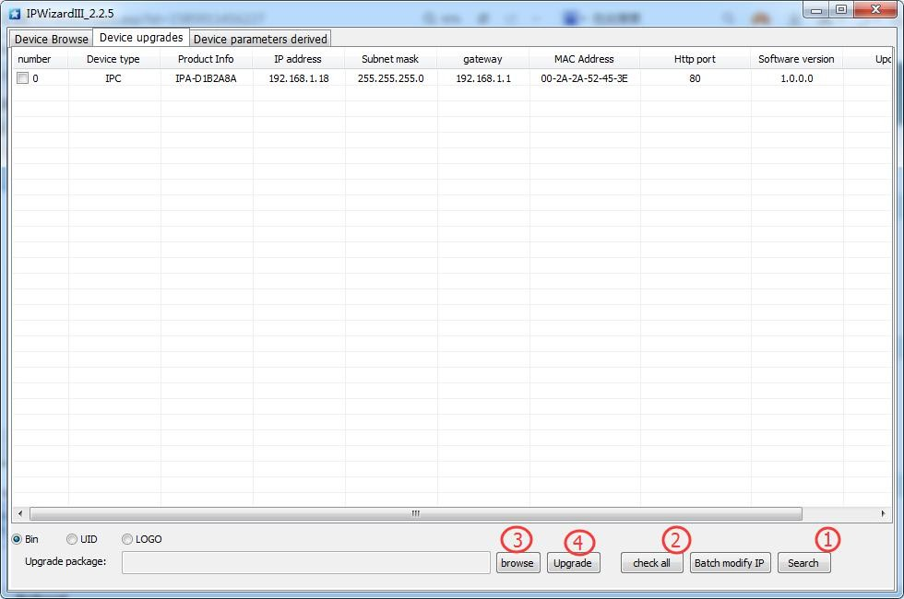

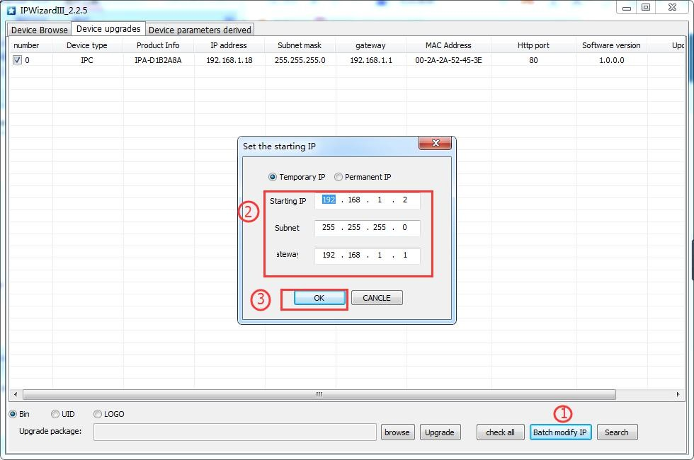Step 2: For multi-devices batch upgrade, user need to modify the default IP address to different one to avoid IP address collision.